**MPU6050**

|  |  |  |  |  |
| --- | --- | --- | --- | --- |
| Serial No. | Name | pinA | pinB | value |
| 1. | C4 | VDD(13) | GND(18) | 0.1uF(C0603)/C0504 |
| 2. | C2 | REGOUT(10) | FSYNC(11),GND | 0.1UF(C0603)/C0504 |
| 3. | C3 | VLogic(8) | GND,GND | 0.1uf (C0603)/C0504 |
| 4. | C1 | CPOUT(20) | GND | 220pf(C0603)/C0504 |
| 5. | R1 | SDA(24) | 3.3V | 4.7k |
| 6. | R2 | SCL(23) | 3.3V | 4.7k |

## Related Link -<https://circuitdigest.com/fullimage?i=circuitdiagram_mic/MPU6050-Module-Internal-Circuit.png>

## We left C-Type, 16V 10uF Semtech Capacitor Capacitor- SMD Tantalum C-Type, 16V 10uF, in MPU6050 because it is only used in power stability

**SIM800L**

|  |  |  |  |  |
| --- | --- | --- | --- | --- |
| Serial No. | Name | pinA | pinB | value |
| 1. | R3 | simRST(15) | Sim holder(RST C2) | 26.1 |
| 2. | R4 | simDATA(14) | Sim holder(C7 I/O) | 26.1 |
| 3. | R5 | Sim_CLK(55) | Sim holder(CLK C3) | 26.1 |
| 4. |  | Sim_VDD(16) | Simholder(C1, VCC) |  |
| 5. |  |  | Simholder(C5,7,8,9,10) | GND |
| 6. |  |  |  |  |

1. XL4015

|  |  |  |
| --- | --- | --- |
|  |  | LM25965-3.3 |
| C1 | 220uF |  |
| C2 | 1uF |  |
| C3 |  |  |
| C4 | 100nF |  |
| R1 |  |  |
| R2 |  |  |
| L1 |  |  |
| L2 |  |  |
| D | MBR340 |  |
| U2 |  |  |
|  |  |  |
|  |  |  |

* XL4015 Buck Converter IC - 1
* 78L05 Voltage Regulator - 1
* LM358 op-amp - 1
* SS54 Schottky Diode- 1
* TL431 Programmable Reference - 1
* 470uF,35V Capacitor - 2
* 10uF 0805 Capacitor -2
* 10K Ten Turns Trim Pot - 2
* 0.1uF Capacitor - 3
* 270R Resistor - 1
* 1K Resistor - 2
* 2.2K Resistor - 1
* 10K Resistor -  1
* 71.5K Resistor - 1
* 90.9K Resistor - 1
* LED 0805 - 3
* Screw Terminal - 2

|  |  |  |  |
| --- | --- | --- | --- |
| **SIM800L U1** | **J1 SIM card** | **ESP32** |  |
| SIM_RST15 | R1 26.1 RST -2 |  |  |
| SIM_CLK 55 | R3 26.1  CLK-3 |  |  |
| SIM_DATA 14 | R2 26.1  I/O-7 |  |  |
| SIM_VDD 10 | VCC -1 |  |  |
| TXD 32 |  | IO25 10pin | D3(1N5819WS)-R4 10K-GND |
| RXD 31 |  | TXD0/IO1 35pin | VDD_EXT-R8 10K -D3(1N5819WS) |
| NETLIGHT 64 |  |  | R7_4.7K-LED(D1)-GND |
| VDD_EXT 18 |  |  |  |
| PWRKEY 48 |  | RXD0/IO3 |  |
| GSM_ANT 40 |  |  | K1 DIPxx-1Axx-1Lx |
| RESET 49 |  |  | Rst sim800l |
|  |  |  |  |
|  |  |  |  |
|  |  |  |  |

Related Photo –

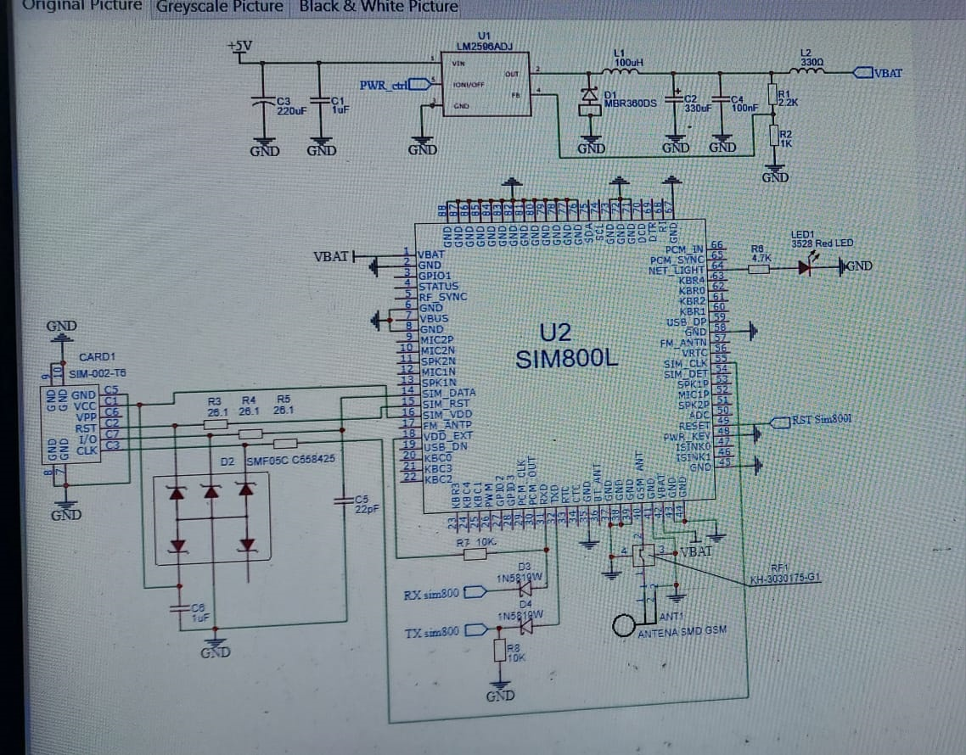

Library-

SIM800L, 693010010601Sim tray(6 Pin ),

**SD CARD MODULE**

|  |  |  |  |  |
| --- | --- | --- | --- | --- |
| Serial No. | Name | pinA | pinB | value |
| 1. | R1 | MOSI | 1A-2 | 3.3k |
| 2. | R2 | SCK | 2A-5 | 3.3k |
| 3. | R3 | DO_LLC | 4A-12 | 3.3k |
| 4. | R4 | CS | 3A-9 | 3.3k |
| 5. | VCC | 14 |  | 3.3V |
| 6. |  | 40E(13) | GND |  |
| 7. |  | 10E(1) | GND |  |
| 8. |  | 7 | GND |  |
| 9. |  | 20E(4) | GND |  |
| 10. |  | MISO | 4Y(11) |  |
| 11. |  | SCK_LLS | 2Y(6) |  |
| 12. |  | DI_LLS | 1Y(3) |  |

Related Link –

[https://circuitdigest.com/fullimage?i=circuitdiagram_mic/Micro-SD-Card-Module-Schematic.png](https://circuitdigest.com/fullimage?i=circuitdiagram_mic/Micro-SD-Card-Module-Schematic.png%20)

**QUECTEL_L89**

|  |  |  |  |  |
| --- | --- | --- | --- | --- |
| Serial No. | Name | pinA | pinB | value |
| 1. |  | VCC | 3.3 |  |
| 2. |  | GND | GND |  |
| 3. |  | RX |  |  |
| 4. |  | TX |  |  |

Related Link -